The scientific flaws of the Committee on Climate Change and the expensive consequences,
Alex Henney, August 2015

SUMMARY

The Committee on Climate Change (CCC) has just published “Reducing emissions and preparing for climate change: 2015 Progress Report to Parliament”. The report reviews a range of low carbon policies with the electric industry centre stage in some of them, notably deployment of renewable electricity generating capacity.

The CCC treats the Intergovernmental Panel on Climate Change (IPCC) as a source of serious science. It is not – its remit is to identify “man’s impact on climate change”, not to study the issue in a broad and scientific manner. Over the years it has included a great deal of junk politicised “science” which has been retracted. Furthermore it is a political body. Its Summaries for Policymakers are signed off by government representatives and on various critical points do not represent the science but spins and evades issues. Climate models are critical to the work of the IPCC including both its (rigged) predictions of future temperature and its attribution of the effect of CO2. Yet for a whole variety of reasons climate models do not (and will not) reflect reality – the climate is too complex, the models too crude.

To substantiate its belief in the need to decarbonise the economy in general – and the electric industry in particular – the CCC makes a number of claims which are either incorrect or exaggerated and presented as though they are a problem. In doing so the CCC frequently exaggerates the figures of the IPCC. The CCC:-

- Neglects to mention that there has been no increase in global temperature for 16-18 years

- Exaggerates the past sea rise round Britain

- Claims without any foundation that “Hundreds of millions of people from small islands to large coastal cities are currently projected to be living in areas that could be submerged”

- States “Ocean acidity will rise which will pose substantial risks to marine ecosystems” – a claim which is based on an ignorance of chemistry and the oceans

- States that “the Arctic sea will become nearly free of summer ice at some point this century”. This is a very unwise forecast to make. Arctic sea ice is variable and over the last three years has recovered much of its recent decline
- Claims that “continual warming increases the likelihood of severe, widespread damage”, a claim in which the IPCC has “low confidence”

- Claims “Average global temperature could rise between 2⁰C and 5.5⁰C by 2100 compared to the late 1800s”. Anything beyond 2⁰C is a scare story with no foundation. A number of solar physicists are forecasting another Little Ice Age

This factually frail rationale (along with the quest by academics for grants and renewables developers for subsidies) is the group think which has driven the British government’s generation policies, which consist of:-

- Building the most expensive nuclear plant in the world

- Subsidising very expensive offshore wind farms which do not achieve what they claim on the tin by way of CO2 mitigation

- Subsidising the largest and most expensive scheme in the world to burn wood chips from new cut trees in the US which actually increases CO2 emissions

- Subsidising residential solar panels in our gloomy climate

- Spending more than any other country researching the unproven prospects of Carbon Capture and Sequestration (CCS)

In reality what we do has no effect on the climate even supposing CO2 has any impact. The Germans and Dutch have just completed 10 large new coal plants. Chinese emissions are now twice US emissions and India’s are 70% of the EU’s and both countries (along with other developing countries) are going hell for leather to build more coal plants.

Going on as we are is not only vastly expensive – effectively a regressive tax on electricity consumers; a burden on energy consuming industry; and a burden on the balance of payments – but unless we build more CCGTs we risk brown-outs if not black-outs in the not too distant future. We are pursuing the politics of illusion and delusion at the expense of an ill-informed public who have to pay for the political caprice.

* * *

The IPCC’s performance

It is important to understand three key features about the IPCC, which is a UN entity. First, its remit is not to examine what affects the climate in general, but to identify “man’s impact on the climate”. Second, it is a political body with all that can imply for low standards of rigour, superficiality, dissembling and spin. Every few years it prepares an Assessment Report gathering together scientific analyses into a report on the Physical Basis Science of some 1500 pages prepared by scientists. This is then turned into a Summary for Policy Makers (SPM) of about 30 pages which is signed off by government representatives. Although the Science report includes a fair amount of solid science, it is led by trusties who are “warmists” who claim that CO2 emissions could lead to dangerous climate warming along with consequential misfortunes and they, to a degree, censor the report. Third, although the IPCC claimed that it only accepted peer reviewed work from scientists at “the top of their profession”, it has promoted a significant amount of deeply flawed science. In 2001 it promoted the discredited “hockey stick” which eliminated the medieval warming period and showed the temperature increasing rapidly in the 1980s to 1990s. It was the basis of the false claim that temperatures had never been higher - it has been dropped. Then in 2007 the 4th Assessment Review was taken apart. Analysis showed that one third of the 18,531 papers were not peer reviewed, including the discredited claim that the Himalayas would be ice free by 2035, and 15 out of 44 chapters were led by WWF affiliated people. Politicians’ claims that the reports are prepared by 2000+ scientists are baseless. Two leading scientists resigned in protest at the misrepresentation which created scares based on fictional increases of malaria and storms which have been withdrawn in the latest Review. Subsequently there was a critical review by the Inter Academy Council.

The latest 5th Assessment Review of 2013 tightened up somewhat, but it still includes sloppy work, advances tenuous propositions, evasive scripting excluded proper consideration of the possible effect of the sun (see below), and did not mention that temperature change precedes change in CO2, both over the long term and the short term, see exhibits.

Vostok ice core records for carbon dioxide concentration and temperature change
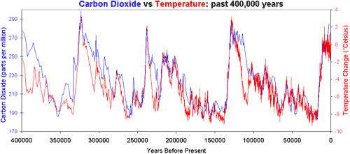

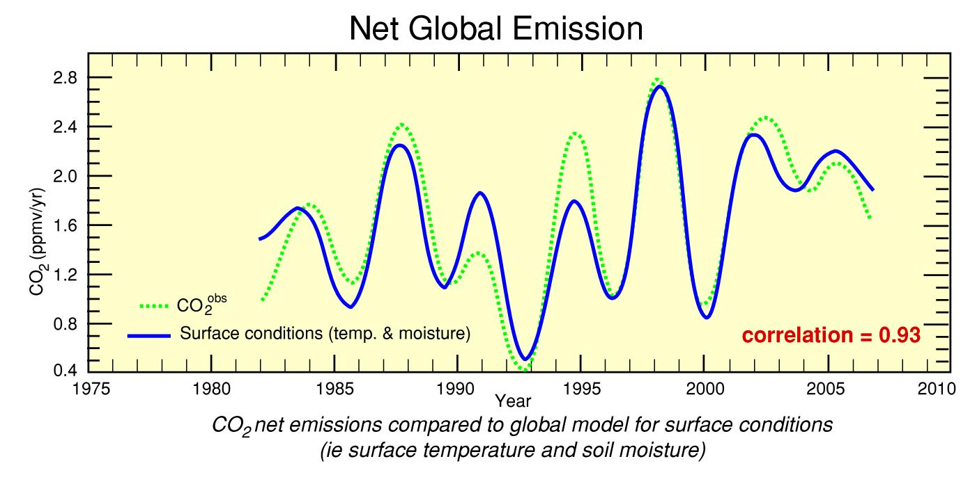
Source: Murray Salsby included in “Climate: What we know and what we don’t”, a summary, The Bruge Group.

Cause cannot follow effect.

The CCC’s science base is not as solid as it should be.

Before looking at the validity of some of the CCC’s claims it is important to examine the accuracy of climate models because they are fundamental to the basic propositions of the CCC that climate change “is caused by emissions [viz mainly CO2] from human activity and leads to significant global risks”, of which the key is rising temperature.

Climate models

Both the attribution of “anthropogenic” climate change and the forecasts of future increases in temperature rely on climate models, which has developed into a significant industry in the climate science world. Attribution is assessed is by running global climate models without a change in CO2 due to human emissions and then comparing the outcome with historic reality for the past and with a forecast including CO2 for the future. The difference in temperature is then attributed to anthropogenic emissions. But the fact is that climate models are not validated – despite the £100Ms poured into them they are not able to simulate past reality.

Professor John Christy has compared the performance of a number of climate models with actual temperature, see exhibit. The black line is the average of the model results; the blue and red are the results of two satellite-based actuals. The models over back-cast temperature significantly.
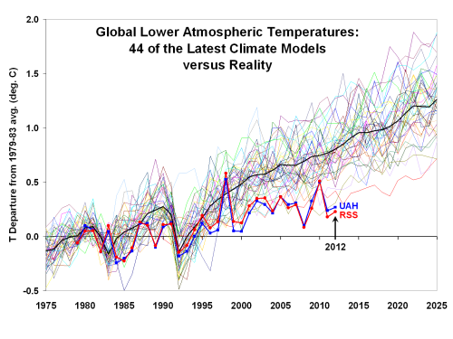
The Met Office has produced a series of incorrect seasonal forecasts of which the “barbecue summer” was only one. In 2007 Met Office scientists wrote a paper “Improved Surface Temperature Prediction for the Coming Decade from a Global Climate Model” which includes a prediction that there would be 0.3⁰C warming over the decade 2005-2014 - there has been no such increase.

There have been numerous papers reporting the inaccuracy of climate models in estimating a wide range of climate behaviour from temperatures, to monsoons, to polar sea ice – models predict a reduction in the Antarctic, but Antarctic sea ice has never been more extensive than now since accurate satellite records commenced in 1979. In his 2012 submission to the Senate Environment and Public Works Committee Christy showed that 31 models underestimated precipitation in the South East of the US. Even the IPCC admits “There are…differences between simulated and observed trends over periods as short as 10 to 15 years (e.g., 1998 to 2012)” (SPM-10). Nonetheless, the vested interest is now so developed that many climate “scientists” seem to confuse models with science and refer to “model experiments”; mistaking non-validated model simulations for reality; and continue to seek more money for faster computers and to develop more “sophisticated” models.

The IPCC 3rd Assessment Report of 2001, p774, recognised reality in commenting “In climate research and modelling, we should recognise that we are dealing with a coupled/non-linear chaotic system and therefore long term predictions of future climate status is not possible.” In a presentation titled “Believing in Six Impossible Things Before Breakfast and Climate Models”, Professor Christopher Essex of the University of Western Ontario, argued that modelling the climate was impossible because first, we did not have fine grained enough temperature data; secondly, we did not understand the equations of the dynamics of the motion of the atmosphere; and thirdly even if we had 1) and 2) we did not have the computational power to model accurately.

Models do not track reality because:-

- They cannot model clouds accurately. The IPCC recognised “there remains low confidence in the representation and quantification of [cloud and aerosol] processes in models” (SPM-11). But clouds are fundamental to simulating the atmosphere

- They all over-estimate “climate sensitivity” – the increase in temperature from a doubling of CO2 – compared with the increasing number of empirical studies of sensitivity which are lower than modelled estimates and imply very modest warming this century

- They have built into them that CO2 is the major driver of the climate, which is not proven

In view of the poor performance of climate models we can place no faith in either their forecasts or their attribution of CO2 to driving climate.

The (in)accuracy of various claims by the CCC

The report sets out the rationale for decarbonisation in chapter 1 “Climate change and the UK” which largely relies on the work of the IPCC entity.

- “The global climate is changing. Sea levels have risen about 20 cm and the average surface temperature has risen by about 0.8°C since the end of the 19th Century. Many other observed changes, such as retreating glaciers and arctic ice, and shifting distributions of species, are consistent with a warming world…Average sea level will increase between 0.5 and 1.1 m by 2100 compared to 1900…In the UK, average sea levels are rising by around 3mm a year”

- Sea levels have been rising for thousands of years since the last ice age due to various reasons of which global temperature is only one. A summary of 70 studies on sea level since 2003 shows not only how complex and uncertain the measurement is. The summary comes to a figure 1.5 + 0.5mm/year, and concludes “that real world sea level rise has been far less dramatic…than has typically been claimed by the world’s climate alarmists”

- “Trends in UK mean sea level revisited” gives the tide gauge mean sea level from 1901 as 1.4 + 0.2mm p.a. DECC’s analysis “UK sea level” looked at the five largest sea level records in the UK for changes in mm from 1920:-

2000 2012
Aberdeen 60 58
Liverpool 139 312
North Shields 198 206
Newlyn 139 152
Sheerness 225 219 (2006)

Only Liverpool shows a rate of 3mm. The research project of the University of Durham of land uplift and subsidence in Britain and Ireland shows a map of some 50 points for Britain with a range of 0.0 to 1.4mm for to which has to be added 2mm for the general global rate of increase. The claim that average sea level will increase by 3mm p.a. is on the high side.

- It is correct that temperatures have risen by about 0.8°C since the end of the 19th century, but the start point for the measurement is the end of the Dalton cool period which was the end of the Little Ice Age. Using satellite/balloon temperature records there has, however, been no increase in temperatures for 16-18 years

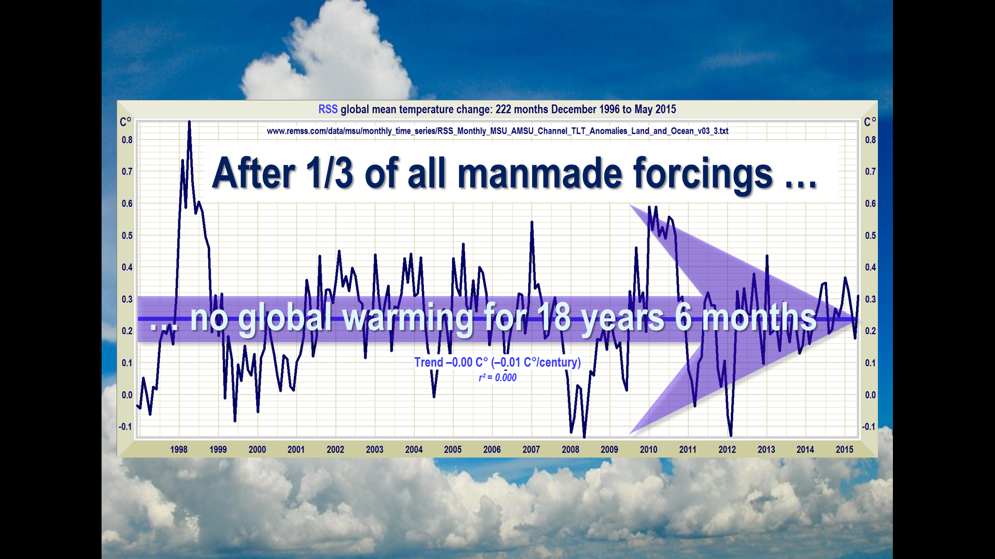

Note that the peak in 1998 was due to the El Nino in the Pacific, which is the warm phase of the Southern Oscillation and is associated with a band of warm water that develops in the central and east-central equatorial Pacific. The cool phase is called La Nina and follows El Nino as happened in 1999 and 2000

- The IPCC went as far as admitting “The rate of warming over the past 15 years (1998-2012; 0.05 deg. C/decade) is smaller than the trend since 1951 (1951-2012; 0.12 deg. C/decade)” (SPM-3)

- Some Alpine glaciers have been retreating for several hundred years and some Antarctic glaciers started to recede in the 19th century, not to mention the much vaunted Furtwangler glacier at the summit of Kilimanjaro

- There is no significant evidence of shifting distribution of species – polar bear numbers have increased as a result of a curb on hunting

- “Hundreds of millions of people, from small islands to large coastal cities, are currently projected to be living in areas that could be submerged. There is potential for higher increases depending on how Antarctic ice sheets respond to further warming.” In fact the Antarctic has been cooling, so that is one less scare to run.

The claim that hundreds of millions of people are living in areas that could be submerged is fanciful. If the threat arises then competent nations will do what the Dutch did a while back in adapting to the sea. There have been populist scare stories (including broadcast on the BBC) about Pacific Islands (e.g. Tuvalu) submerging. In fact coral islands rise as the sea rises; a number have increased in area; in Tuvalu sea level has fallen by 4 inches in a decade.

- “Average ocean acidity will rise, as the sea absorbs carbon dioxide. This will affect the ability of corals and other shell-forming organisms to grow, posing substantial risks to marine ecosystems.”

This proposition shows an ignorance of basic chemistry. The oceans are powerfully self-buffered to preserve homoeostasis in the current alkaline/acid balance at pH 7.8-8.0 (7.0 is neutral; rainwater is acidic at 5.4). Carbon dioxide in the oceans reacts with carbonate rocks to produce a mildly alkaline solution of bicarbonate. As geologist Professor Ian Plimer observed “The oceans can only become acidic if the earth runs out of rocks.” In the past coral has thrived when the level of atmospheric CO2 was much higher than currently.

- “Coverage and thickness of ice and snow will decrease, with the Arctic Sea becoming nearly free of summer ice at some point this century.”

In fact Arctic ice has been increasing during the last three years. If we look to the past we find:-

“The Arctic is warming up, icebergs are growing scarcer and in some places the seals are finding the water too hot. Reports all point to a radical change in climate conditions and hitherto unheard-of temperatures in the Arctic zone.”

US Weather Bureau, 1922
Similar statements are available for 1957; the US submarine Skate surfaced at the North Pole on 11 August 1958.

A little knowledge of the Arctic in the past and the fallacy of Al Gore’s prediction that Arctic summer ice would probably disappear by 2014, should caution against such a prediction as the CCC has made.

- “It is clear that continued emissions will lead to further warming”. In fact since satellite records began in 1980 the temperature in the Antarctic has been constant and the Southern Ocean sea surface temperature has been way below average since 2005.

The IPCC comments “Low confidence” that damaging increases will occur in either drought or tropical cyclone activity (SPM-23, Table SPM.1).
Not only is the effect of further emissions unknown, as pointed out below there are solar physicists who forecast a cooling period to come.

- “Average global temperature could rise between 2°C and 5.5°C by 2100 compared to the late 1800s. This is well beyond any global temperature change experienced during the course of human civilisation. Warming will be greater over land than the global average and especially pronounced in northern latitudes. Regional weather will change as phenomena such as monsoons, jet streams and storms change with the warming.”

Given the worthlessness of climate models this is merely baseless scare fantasy of the type promoted by state scientists seeking grants and politicians wanting to make money from subsidised renewables or to save us. As H.L. Mencken observed:-

“The whole aim of practical politics is to keep the populace alarmed (and hence clamorous to be led to safety) by menacing it with an endless series of hobgoblins, all of them imaginary.”

Richard Feynman in one of his lectures said:-

“It doesn’t matter how beautiful your theory is. It doesn’t matter how smart you are, if it doesn’t agree with experiment, it’s wrong”.

This advice applies equally to the IPCC and CCC and their theory that CO2 is driving the temperature of the climate and will have various adverse consequences.

Ignoring the sun

The report claims “Detailed studies of alternative causes (such as variations in energy received from the sun) demonstrate that they cannot explain the sustained, widespread warming and other changes that are underway.”

It is true that the change in total solar irradiance from the eleven year solar cycle is not enough to significantly affect the climate. But that is the only solar effect which the IPCC examines because to admit the sun has a significant effect would undermine the CO2 story. There is, however, increasing evidence that via its influence on cloud formation the sun has a significant effect on the climate – over 200 peer reviewed papers demonstrating solar control of the climate have been published since 2010. (At lower levels the net effect of more cloud cover is to cool the earth by reflecting incoming sunlight). Even the warmist Met Office has admitted as much in a recent paper. There are a number of solar physicists who anticipate that the current solar cycle which has low activity will be followed by even lower activity cycles including the Russian solar physicist Habibullo Abdussamatov (who is not behoven to a US or major European government for grants). He has opined that the continuing reduction of the sun’s activity will lead to a little ice age in the middle of this century.

Meanwhile in the real world

One of the most presumptuous claims of recent British governments was that we were going to “lead” by example, a pretentious claim which the EU also adopted. And now Obama wants the US to not only follow suit, but stride into the lead. But while we put on a hair shirt and obsess about burning coal the Dutch and Germans have over the last five years commissioned 10 large supercritical coal plants. The Chinese, Indians and others have been building coal plants at a rapid rate; indeed the Chinese have recently agreed to finance a coal plant in Pakistan and another in Zambia. In consequence coal consumption over the last decade has increased from 1125MTOE to 1962MTOE and from 172MTOE to 324MTOE in China and India respectively, and now China’s CO2 emissions are about twice those of the US and India’s are 70% of the EU’s.

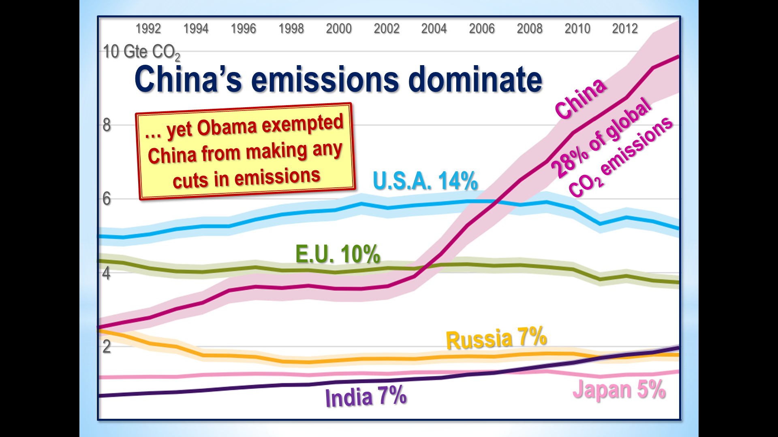

According to EurActive published by the EU, China has 117GW of coal plant under construction with 612GW in the pipeline, while the figures for India are 69GW and 360GW and for Vietnam are 17GW and 61GW. The future for coal consumption looks reasonable, notwithstanding Britain’s intention to cut all 37MTOE consumed in 2014 by 2030. None of the coal guzzling countries are going to reduce soon as the forthcoming climate charade in Paris will demonstrate.

Britain’s expensive and unwise generation policies

The views expressed by the CCC reflect the PC views of many politicians, civil servants, academics seeking grants and developers seeking renewables subsidies, and are responsible for the British government’s generation policies to:-

- Build the most expensive nuclear plant in the world costing £16bn (£24bn including interest during construction) for a mere 3200MW

- Subsidise very expensive wind including planning consent for the largest and most expensive wind farm in the world (Forewind) that is estimated to cost £6-8bn. Offshore wind costs three times the current wholesale price of electricity, and sends vast sums of money overseas. A blog “The UK Offshore Wind Industry” analysed Renewable UK’s report “Offshore Wind Project Timelines”, which calculates the subsidies payable to wind farms already operating and those under construction and likely completed by 2022. “With output of 62TWH p.a. gives an annual subsidy of £6 billion…and all guaranteed for 15 years…The share of UK companies Centrica and SSE only amounts to 17%, meaning that the vast bulk of subsidy will be sent abroad…The wind industry creates very little added value, while Siemens and Vestas dominate the manufacture of turbines.” When the “market” income from the subsidy is added to the subsidy we get to a total of £10bn p.a., which the author opines “the UK simply cannot afford.”

Furthermore, based on empirical data from Ireland and the US, windmills in a thermal based system like ours only achieve about 60% of the mitigation of CO2 which they claim on the tin because the cycling of CCGTs to balance the variability of the wind (and solar) reduces their thermal efficiency and increases their CO2 emissions

- Subsidise the largest and most expensive scheme in the world to burn wood chips from new cut trees in the US which actually increases CO2 emissions and destroys the environment. Journalist David Rose went to North Carolina to see the operation by Enviva cutting down mostly hardwood trees to make into more than a million tons annually of pellets that are transported 3800 miles to Drax in Yorkshire to generate £62M in subsidy in 2013. Drax’s head of environment admits the wood fuel produces 3% more CO2 than coal and twice as much as gas. Surely even by DECC’s low standards this is a lamentable waste of money

- Spend more than any other country researching the unproven prospects of Carbon Capture and Sequestration (CCS), which is a saga that started in 2003. Recently E.On in the Netherlands pulled out of developing perhaps the most favourable project of installing a post-combustion system of 250MW on a new coal plant it is building at Maasvlakte; after a decade Vattenfall is reported as stopping research on CCS; the costs of renovating and installing CCS to the 30 year old Boundary Dam power plant in Saskatchewan is very high, and incurs a parasitic loss of about 32% of the plant’s power and there is a thermal efficiency loss of at least 25%

- Subsidise residential solar panels in our gloomy climate with subsidies which make nuclear look cheap

- Run an indiscriminate capacity auction when what is required is capacity to balance wind variability

These are very unwise policies which will cost consumers dear. The “Levy Control” – a subsidy limit - for 2020 is budgeted at £7.6bn (2011/12 prices) most of which is for electricity decarbonisation measures which DECC estimates will add an average £92 (2014 prices) on household energy bills by 2020 of which about 4/5 will be on electricity. DECC’s Impact Assessment for 29% renewable electricity assessed the present value of its cost up to 2030 as £39bn offset by carbon savings valued at £6bn leaving a net cost of £33bn”, which does not seem a good deal. Worse, if the unwise policies are pursued for much longer they could, together with the closure of more coal plants and brown-outs if not black-outs in the not too distant future. They are the politics of political correctness and the policies of illusion and delusion.

* * *

The CCC’s grasp of the realities of both the climate and of power generation is tenuous, and consequently its rationale for decarbonising the economy bears little scrutiny. It is easy to rattle off a mantra about increasing temperatures, more storms, fewer polar bears etc. which has been plugged by the BBC and other media for years and is run by green politicians and NGOs. But few people are aware of the relevant facts and in the short term the cost consequences of the policies are hidden from them by dissembling politicians, officials and activists – until it is too late and they are obliged to pick up the tab.

It is easy to indulge in uncritical group think, the more so when the groupers have transmuted the issue into a quasi-religious one of “saving the planet”, which excites moral passions. Climate group think is promoted through control of various governmental agencies from the UN to HMG, the Parliamentary Committees on Energy and Climate Change and Science and Technology, the Met Office, the Royal Society, and control of research grants which excludes dissenters. The groupers have attempted to close down debate through control of media such as the BBC and journals such as Nature, and the fallacious claims that 1) science is settled, and 2) there is a consensus, neither of which are true. (Fortunately they cannot control the blogosphere where there are some excellent “sceptic” blogs). In reality many groupers are not well equipped to handle debate because if truth be known many are not aware of the facts of climate science, take no trouble to look at alternative arguments, and can do little more than reiterate the mantra. Instead of engaging, some simply ignore sceptic views and facts that do not agree with their prejudices and too many indulge in vituperation (climate “deniers” etc.).

When the group think is politicised, it involves politicians’ face and too often a descent to a superficiality and ignorance of facts (or deviousness from those who are benefiting) together with commercial vested interests who seek subsidies. In the case of climate science beneficiaries we must include a myriad of academics and consultants seeking grants by being PC. We have created substantial interests from groups who are supplicants to politicians and civil servants for cash forced out of electric consumers who have no idea what is really going on. We have even descended to Big Oil by way of six European companies prattling about saving the planet with a CO2 tax, which is about as commercially cynical as it gets. They know their oil and gas markets are safe, while a CO2 tax would hit coal proportionately more.

As General Patton once commented “If everyone is thinking the same, no one is thinking”. We sceptics have to play a long game of allowing Mother Nature to reveal her real self and show up group think for the superficial fashion which it is.

I was on the board of London Electricity 1981-84. My report “Privatise Power” published by the Centre for Policy Studies in February 1987 was the first to propose a competitive restructuring of the electric industry with a pool. After the election in June I was involved with Rt. Hon. Cecil Parkinson and officials in the early days of restructuring, and wrote a paper “The operation of a power market” which had an influence on the course of events. Subsequently I have advised on electric markets from Norway to New Zealand.
The statistical analysis underlying the “hockey stick” was criticised by two Canadians and confirmed for a Congressional Committee by a leading statistician. Journalist Mark Steyn has just published “A disgrace to the Profession” about Professor Michael Mann who was the leading, and most aggressive, advocate of the hockey stick.
This was an embarrassment to the CO2 storyline because the temperature was high when the level of CO2 was low.
Canadian journalist Donna Laframboise spent a couple of years examining the behaviour of the IPCC. What she found is reported in “The Delinquent Teenager who was Mistaken for the World’s Top Climate Expert” and is an indictment of its behaviour.
Professor Paul Reiter of the Institut Pasteur is a world leading specialist on malaria. He set out his concerns about the ignorance of those involved in reviewing malaria for the IPCC in a Memorandum to the House of Lords Select Committee on Economic Affairs, The Economics of Climate Change, 31 March 2005, HL Paper NO. 12-11. The Scientific Assessment of AR5 concluded (p1002) “The many findings described above make it clear a vast body of scientific examination and research contradict the claim that malaria will expand across the globe and intensify as a result of CO2-induced warming.”
Which is NOT to say CO2 is not a greenhouse and has a warming effect.
See Murray Salby’s talk http://youtube.com/jZ0.R1MCkSOU.
John Christy is Professor of Atmospheric Science and Director of the Earth System Science Center at the University of Alabama in Huntsville, and is Alabama’s State Climatologist. He was a lead author in the 2001 IPCC Report and a “key” or “contributing” author on others. The University’s satellite based temperature dataset is one of the 5 main data sets that are widely used.
He also had many wise points to make about the climate in the US; about so called extreme events; about the IPCC; about consensus “science” which by definition is not science, and the imperceptible effect on global temperature of the proposed changes in greenhouse gases then envisaged.
http://wattsupwiththat.com/2015/02/20/believing-in-six-impossible-things-before-breakfast-and-climate-models/.
Oversensitive: How the IPCC hid the good news on global warming, Nicholas Lewis and Marcel Crok, 06/03/2014, Global Policy Warming Foundation.
http://www.C02science.org/subject/s/summaries/sealevelglobal/php.
Geophysical Journal International, Volume 176, Issue 1, Article first published online: 28 NOV 2008, http://nora.nerc.ac.uk/8319/
They avoid the increasing adjustment of “official” surface temperature recordings which are being manipulated in Australia, Britain, and the US to decrease temperatures in the middle decades of the last century and increase in the latter decades thus increasing the apparent warming.
NotALotOfPeopleKnowThat, 15/08/2015/
https://notalotofpeopleknowthat.wordpress.com/2015/01/23/no-warming-in-antarctica-during-satellite-record/.
NotALotOfPeopleKnowThat, 23/01/2015.
Hockeystick.blogspot.co.uk/2015/02.
Regional climate impacts of a possible future grand solar minimum, Sarah Ineson, Amanda C. Maycock, Lesley J. Gray, Adam A. Scaife, Nick J. Dunstone, Jerald W. Harder, Jeff R. Knight, Mike Lockwood, James C. Manners & Richard A. Wood, Nature Communications 6, Article number: 7535.
Current Long Term Negative Average Annual Energy Balance of the Earth Leads to New Little Ice Age.
Figures from BP Statistical Review of World Energy 2015.
NOT A LOT OF PEOPLE KNOW THAT, 5/1/15.
The Economist of 10/1/15 carried an article “Britain’s biggest export: wealth” which pointed out that because overseas returns have reduced “net investment income has fallen from a peak of 3% of GDP in the second quarter of 2005 to minus 2.8% today. That has caused the current account deficit to swell to 6% of GDP even as the trade balance has improved…. This has worrying implications for the sustainability of Britain’s recovery.”
Alex Henney, Fred Udo, Wind – Whitehall’s pointless profligacy, New Power, Issue 45, October 2012.
DECC produced a report “Life Cycle Impacts of Biomass Electricity in 2020”, July 2014, which went in great detail into the CO2 consequences of many variants of wood residue/chips of which the higher volume variants, such as cutting down intensively managed plantations, do not reduce CO2 emissions when account is taken of sequestration from cutting and regrowing the forest But it carefully did not point out that the CO2 mitigation from the expensive subsidy paid to Drax is negligible. Perhaps all the cases were included to obfuscate the basic issue.
The bonfire of insanity, Mail on Sunday, 16/3/14.
The Daily Telegraph of 28/8/2015 reports that subsidies for residential solar panels are going to be cut.
Estimated impacts of energy and climate change policies on energy prices and bills, DECC, November 2014.
Impact Assessment of proposals for a UK Renewable Energy Strategy – Renewable Electricity, DECC, URN 09D/686, 10 July 2009, http://www.decc.gov.uk/assets/decc/what%20we%20do/uk%20energy%20supply/energy%20mix/renewable%20energy/renewable%20energy%20strategy/1_20090715120351_e_@@_ukrenewableenergystrategy2009iaforrenewablecentralisedelectricitysectorurn09d686.pdf.
As the electric industry and British government showed in the 1960s to 1980s about the alleged favourable benefits of “cheap” nuclear power when the mantra was Co(al) - Co(nservation) - Nuc(lear), which was recited by people who had no idea of the costs of nuclear. Some other British examples of group think have been the misinformation underlying the long running scare about unsaturated fats and the associated PR for a low-fat high carb diet; light handed regulation for the banking industry; the enthusiasm for joining the euro espoused by many.
Although the last three presidents of the Royal Society are eminent in their fields they know little beyond the mantra and have on occasion exposed the limitations of their knowledge in public. But that has not stopped them airing their climate views, and encouraging a small group of members to publish reports on climate change which are both superficial and breach the Society’s founding charter which prohibits it from expressing a corporate view. Perhaps the fact that 68% of its income comes from HMG is part explanation of this behaviour coupled with a desire to be politically important.
Professor Julia Slingo, Chief Scientist of the Met Office and a keeper of the flame, is on the board of the National Environmental Research Council where she can act as grant gatekeeper.
A perfect example of this aspect of group think was the report by the Energy and Climate Change Committee of Parliament in 2014 when it was considering the IPCC’s scientific Report of September 2013. Although there were an equal number (11) of submissions from sceptic scientists as there were from the British warmist establishment and 17 of the 18 submissions by public policy analysts were critical of the IPCC (analysis in submission IPC 0056 by Alex Henney), the Committee’s report was a ringing endorsement of the IPCC’s work. Could it be that the chairman, Tim Yeo MP, was earning some £200,000 p.a. from companies with renewables interests influenced the outcome?

